

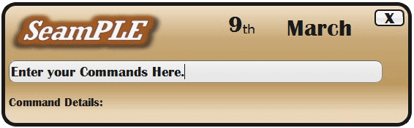

  Liu Weiyuan  Programmer, Designer, Content Producer |   Riandy  Content Producer, Programmer, Time-Keeper |   Cham Wen Bin  Leader, Designer, Programmer |   Pan Wenren  Programmer, Designer, Content Producer |   John Francisco  Programmer, Designer, Content Producer
A User Manual
V 0.1

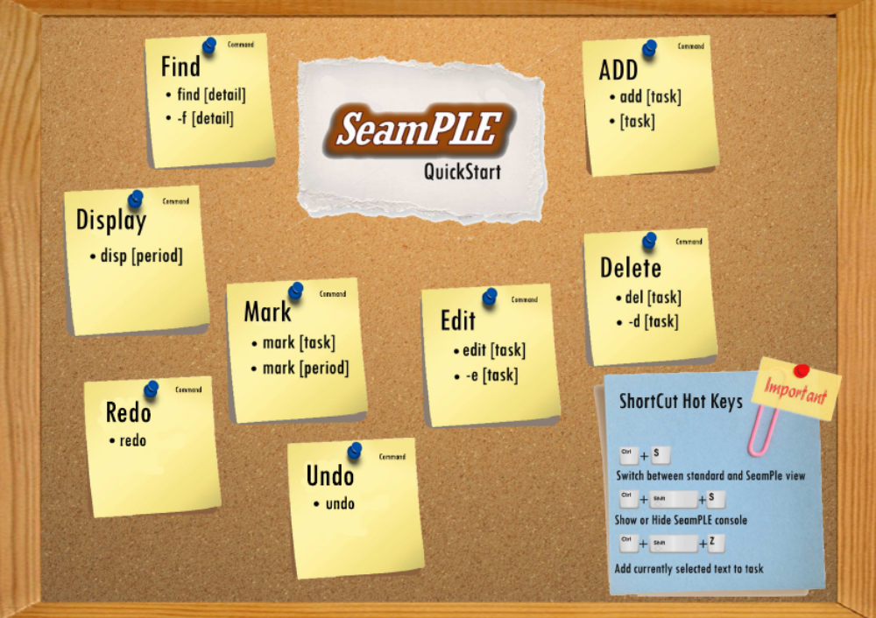
[F09 - 1C][V0.1]
What is SeamPLE Software?
SeamPLE is a todo list widget that is aimed at allowing users (you!) to have total control over day-to-day events. We help you achieve this through our simplistic yet intuitive user interface, as well as our intelligible widget command list.

Getting SeamPLE to run
Operating System Requirement: WindowsXP/WindowsVista/Windows7[RECOMMENDED]
To run the program, double click SeamPLE.exe icon. (Simple, ain’t it?)

Experiencing SeamPLE
There are two views to our SeamPLE application: SeamPLE view and Standard view

SeamPLE view Standard view
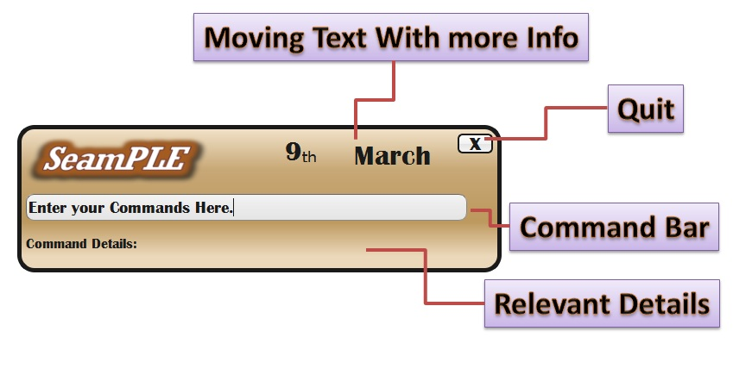
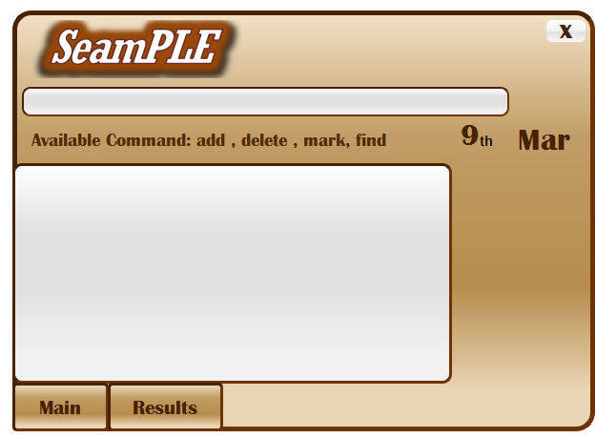

SeamPLE view is seen most regularly as a toolbar notification while Standard view is seen only when the program is maximised.
Using the Standard view offers the user more customization options, such as having the ability to check through the day's events and tasks or even searching for an event that is keyed into SeamPle previously. The SeamPLE view offers the user an alternate and more convenient way of using the program, by allowing the user to issue commands quickly without the need for maximizing the widget view.
To view the different commands that can be used with SeamPLE, please flip to the next page.

Command Walkthrough

ADD
Description: Use this command to add a specific task that you want.
Just type the detail that you want and SeamPLE will help you to manage them!
Command : add [task] [date] [category] [time] [priority] 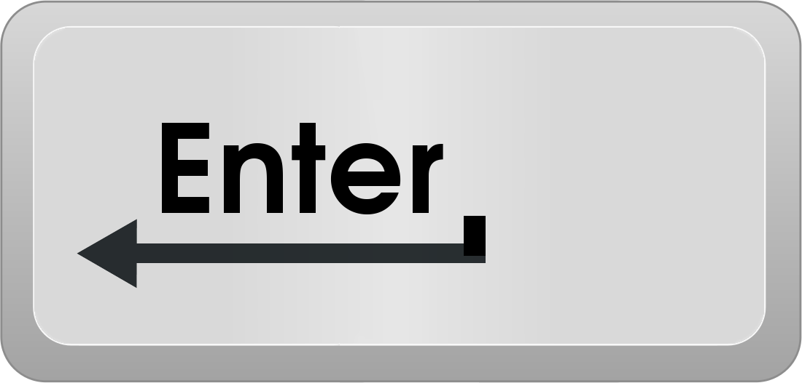
: [task] [date] [category] [time] [priority]
Ex: add dinner With mary → Add task into today’s list of things to do.
Meet investors Monday → Add task into the upcoming Moday.

Edit
Description: Use this command to edit any details of a specific task.
Just type the details that you want to edit and SeamPLE will update accordingly!
Navigate across fields that you wish to edit with the tab button.
Command : edit [task] [date] [category] [time] [priority]
: -e [task] [date] [category] [time] [priority]
Ex: Edit meeting HIGH → Edit task’s Priority to be high .
-e homework Monday → Edit task’s Date into the upcoming Moday.

Delete
Description: Use this command to delete any specific task.
Just type the task with the ID that you want to delete and SeamPLE will clear them!
Command : del [task ID]
: -d [task ID]
Ex: del 101 → Delete Task “Tennis with Jamie” . (Task embedded with ID 101 is deleted)
-d 34 → Delete Task “Walk dog”. (Task embedded with ID 34 is deleted)

Find
Description: Use this command to find a specific task that you want or even list out several task with the same category. Just type the detail that you want and SeamPLE will help you list all of them!
Command : find [category] , find [event name],
find [event ID]
: -f [category] , -f [event name], -f [event ID]

Ex: Find meeting → List all tasks that contains the word “meeting”
Find 101 → Show the task “Tennis with Jamie”.

Display
Description: Use this command to display all tasks
Command : dsp
: display
Ex: dsp → Show all tasks that are saved in text file

Mark
Description: Use this command to mark/unmark your events/tasks. You can mark the tasks that you have done and put it in archive and also unmark an event if you accidentally mark it done. Besides that you can also mark all the past events or tasks that have passed it’s deadline.
Command : mark [task] [period]
Ex: mark meeting with John → Mark “meeting with John” event done
mark yesterday → Mark all yesterday events/tasks done.

Note : command in red is optional. But you have to provide at least one of it to guarantee that the command you want is executed.

Undo
Description: To revert the latest change made by the user. To allow the user to reverse the command of the alsto cancel or reverse the last command added
Command : undo

Redo
Description: To reverse an undo operation
Command : redo

Architectural Style
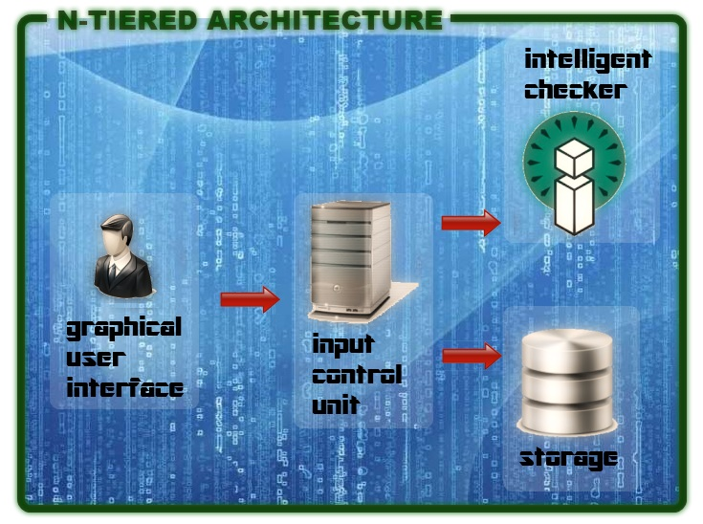
SeamPLE utilizes the N-Tiered Architectural style to power its operations. Starting with the highest level, users interact with various Graphical User Interfaces (GUI) that have been prepared specially for them. This input is sent to the Input Control Unit (ICU) which takes control of this input and decides whether it should be sent to the Intelligent Checker (IC) for validating the input or the storage for running the user inputs and storing or retrieving the appropriate details.

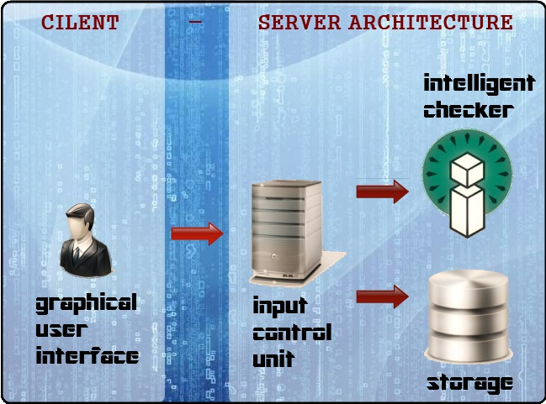
SeamPLE has been cleverly engineered to suit developers’ needs and purposes. By adopting the approach of attaining minimum coupling between the GUI and the ICU, we allow the GUI and other components of the products to be easily exchangeable with other developer created classes. The “Client” Component, as represented by the GUI, can be easily exchanged with other developer created GUI or even the command prompt. The “Server” component, as represented by the rest of our system, can be replaced by developer classes to process any possible user inputs.

Next, we’ll be looking at the overall class diagram of SeamPLE. The class diagram is an essential tool for any prospective developers to continue development or to create new innovations from out system.

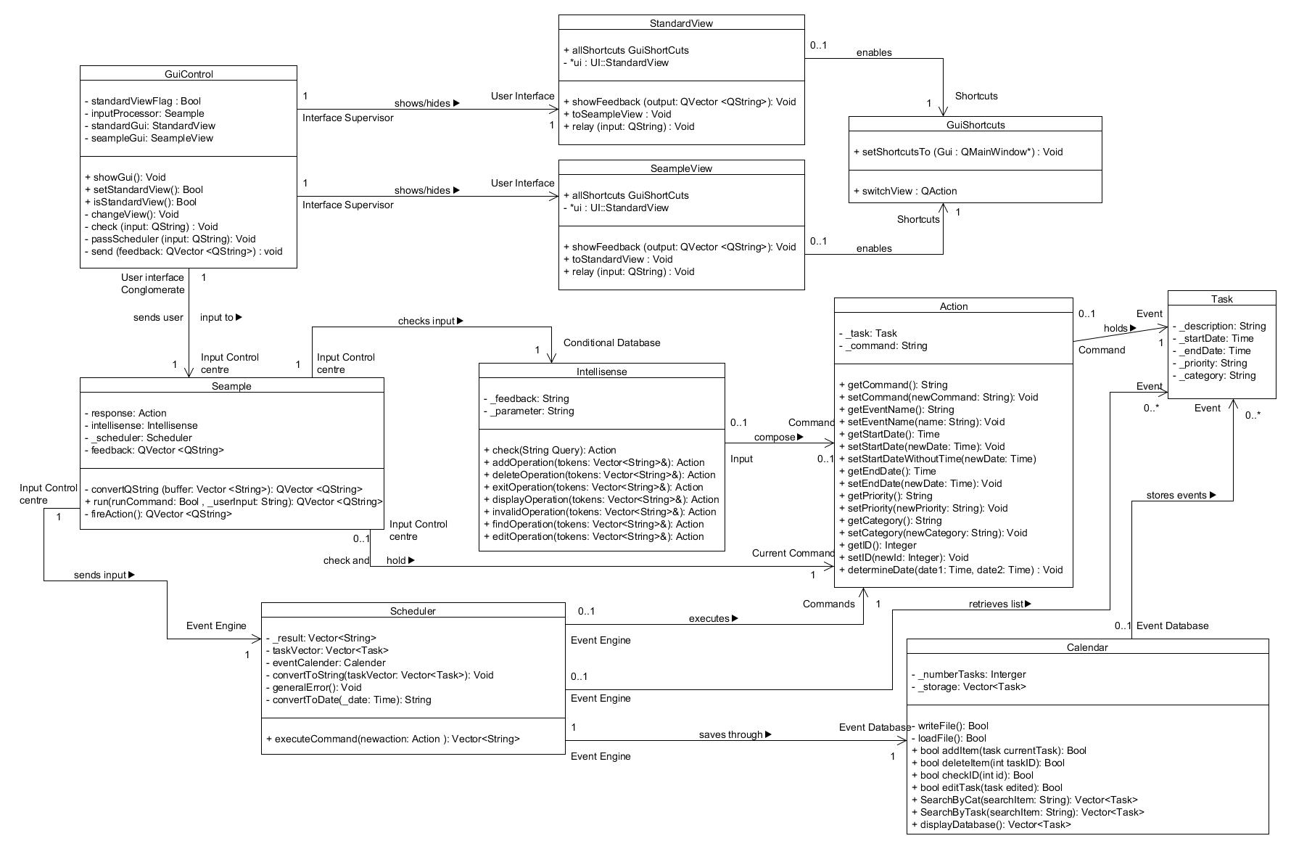
Next, we’ll be looking at the overall class diagram of SeamPLE. The class diagram is an essential tool for any prospective developers to continue development or to create new innovations from out system.

Through the class diagram of SeamPLE, the different relations between the various components are explored. It is important to note that GuiControl must always contain exactly one instance of Seample and Seample must be owned by one instance of GuiControl. This supports the Client – Server architecture that was mentioned earlier on, where one unique client can have only one relation with another unique server.

API Descriptions

Next, we look at possible API descriptions for our program. The API descriptions support what we have implemented in the class diagram above. These descriptions can be used for further implementation (extending on current purposes) and testing (for writing stubs that emulates component behavior)

GUI CONTROL class

send
Description
Function to display feedback to users through the GUI. Call this function when a component wants to interact with the user. API will display all elements accordingly.
Syntax
void send(QVector <QString> feedback)
Input value(s): Qvector of Qstrings containing feedback strings
Return values (s) : None. Output displayed by GUI

passScheduler
Description
Event trigger function when “enter” key is pressed. Function will call scheduler to execute user’s command.
Syntax
void passScheduler(QString input)
Input value(s): Qstrings containing user command input
Return values (s) : None. Output displayed by GUI
check
Description
Calls for intellisense.check to parse user command input.
Syntax
void check(QString input)
Input value(s): Qstrings containing user command input
Return values (s) : None.

INTELLISENSE class
check
Description
Parses user’s command input in the textfield into Action files
Syntax
Action check(string query)
Input value(s): String containing user command input
Return values (s) : None.
getParameter
Description
Determine the input requirements from user command input and generates a feedback string to inform the user of the required fields.
Syntax
string getParameter()
Input value(s): None
Return values (s) : String of colour coded feedback indications

SCHEDULER class
executeCommand
Description
Performs the relevant actions based on the type of operation, input fields.
Syntax
vector<string> executeCommand(Action newaction)
Input value(s): Action class containing input field information
Return values (s) : Vector of string containing feedback messages depending on operation.
Calender
addItem
Description
Stores a user task into the database.
Syntax
bool addItem(task currentTask)
Input value(s): task class containing input field information
Return values (s) : Boolean true if operation is successful false otherwise.
deleteItem
Description
Remove a user task from the database .
Syntax
bool deleteItem(int taskID)
Input value(s): task class containing input field information
Return values (s) : Boolean true if operation is successful false otherwise.

editTask
Description
Edit a user task in the database .
Syntax
bool editTask(task edited)
Input value(s): task class containing input field information
Return values (s) : Boolean true if operation is successful false otherwise.
displayDatabase
Description
Display all user tasks in the database .
Syntax
vector<task> displayDatabase()
Input value(s): None
Return values (s) : Vector containing all task information
CALENDAR class
SearchByTask
Description
Search all user tasks in the database based on task ID.
Syntax
vector<task> SearchByTask(string searchItem)
Input value(s): string containing search field
Return values (s) : Vector containing all task information
SearchByCat
Description
Search all user tasks in the database based on task category.
Syntax
vector<task> SearchByCat(string searchItem)
Input value(s): string containing search field
Return values (s) : Vector containing all task information

